Programming Displays in RoboPro Name:
Learning Target: I can create automation through construction and programming
Supporting Target: I can program automation systems to meet a need
www.opencim.weebly.com > Robots in Manufacturing > Automation in Manufacturing >
Automation with RoboPro > Programming Automation systems > Simulation Mode
Instructions:  - Watch Video  - Create a file and save  “Your Name Display.rpp”  - Create the code that displays your name when you press a button and goes blank when you release the button.  *Note* Use another text element and panel display | After completing the assignment:  1) Why is it important to know your display’s character length?  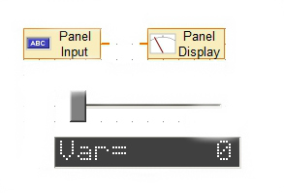  2) Try to program a slider to display its value using these elements:  Save the file as “Your Name Slider Display
Programming Displays in RoboPro Name:
Learning Target: I can create automation through construction and programming
Supporting Target: I can program automation systems to meet a need
www.opencim.weebly.com > Robots in Manufacturing > Automation in Manufacturing >
Automation with RoboPro > Programming Automation systems > Simulation Mode
Instructions:  - Watch Video  - Create a file and save  “Your Name Display.rpp”  - Create the code that displays your name when you press a button and goes blank when you release the button.  *Note* Use another text element and panel display | After completing the assignment:  1) Why is it important to know your display’s character length?  2) Try to program a slider to display its value using these elements:  Save the file as “Your Name Slider Display

